Submissions online before March 3, 2025 (midnight):
https://sondages.inrae.fr/index.php/728465?lang=en
SPS Research Open call 2025 | 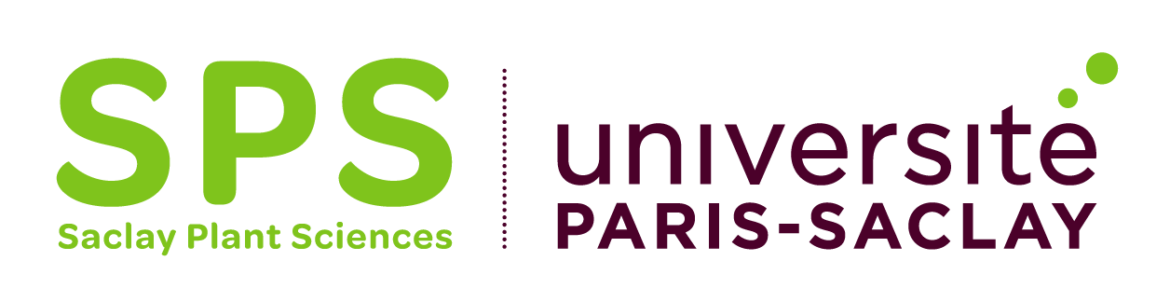

Title of the project:

Acronym:

Keywords:

Scientific coordinator(s) (SURNAME First name, Institution, Laboratory):

Total cost of the project (max. 40k€ requested to SPS):
Detail of the expenses | Type of expenses  (Recruitment, Running costs, Equipment) | Cost | Funding source  (SPS, if relevant cofunding by other sources > precise the source and the funding status)
TOTAL

Abstract (250 words)

