Submissions online before June 20, 2024(midnight): https://sondages.inrae.fr/index.php/552877?lang=en
SPS PhD Fellowships 2024 | 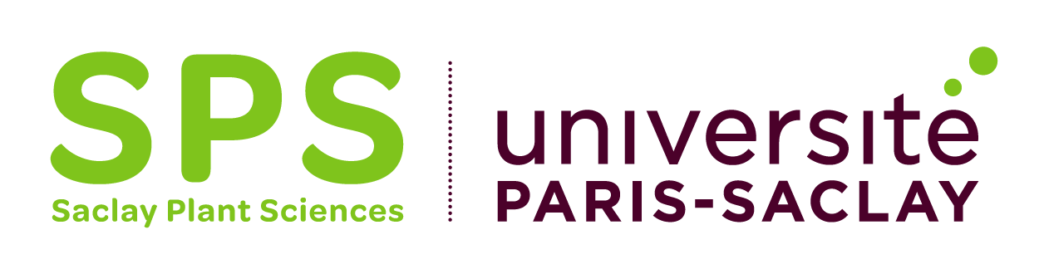
This application can be written in English or in French.
Application deadline: June 20, 2024 (midnight)

Part 1
Name of the PhD applicant:

Project title:
Project title in English (if the project is written in French):

Keywords:

PhD supervisor:  Name:  Institution:  Laboratory:  Email:  Signature: | Research unit director:  Name:  Signature: | Doctoral School:  Name of the Doctoral School:  Name of the Director:  Email:  Signature:

Other PhD students currently supervised by the PhD supervisor:

Last name | First name | PhD start date | Funding source

Other sources of funding that will be used for the PhD project:

Funding source | Type of funding  (ex: operating costs, travel…) | Funds that will be used for the PhD  (in euros)

Part 2

Abstract (250 words)

Description of the project (context, objectives, method and strategy, provisional planning, expected outputs, references…) (max. 2500 words excluding references and figures)
Note: a project description containing more than 2500 words will not be eligible!

